**Image-to-Geometry Registration on Mobile Devices – Concepts, Challenges and Applications**

Melanie Kröhnert*, Christian Kehl†‡, Herbert Litschke₮, Simon J. Buckley‡

*Institute for Photogrammetry & Remote Sensing, TU Dresden, Helmholtzstr. 10, D-01069 Dresden, melanie.kroehnert@tu-dresden.de

†Aix Marseille Uniersité, CNRS, IRD, CEREGE UM34, Sedimentary Systems and Reservoir Development, Marseille, France

₮Hochschule Wismar, Philipp-Müller-Straße 14, D-23966 Wismar

‡Uni Research AS – CIPR, Nygårdsgaten 112, NO-5008 Bergen

**Abstract.** text text text text text text text text text text text text text text text text text text text text text text text text text text text text text text text text text text text text text text text text text text text text text text text text text text text text text text text text text text text text text text text text text text text text text text text text text Mehr Platz darf ich nicht einnehmen! text text text text text text text text text text text text text text text text text text text text text text text text text text text text text text text text text text text text text text text text text text text text text text text text text text text text text text text text text text text text text text text text text text text text text text text text text text text text text text text text text text text text text text text text text (Arial 8)

**1 Introduction**

Considering the worldwide distribution of 5.3 billion unique mobile subscriptions with a smartphone percentage of 56 % compared to global population of ~7.5 bililon people [1], a life without smartphones seems to be not imaginable nowadays. Smartphones with inbuilt cameras, powerful processing units and low-cost positioning systems seem to be very suitable wide-spread measurement devices that could be used for mobile mapping, measuring and visualisation purposes [2]. Here, image-to-geometry intersection describes an essential topic for the translation of mobile captured image data into object space which allows for metric interpretation on call. Section 2 illustrates state-of-the-art concepts for solving the issue of image-to-geometry intersection whereas section 3 depicts challenges regarding the precise determination of camera´s intrinsic and extrinsic parameters and points out the issue of their geometric stability. Furthermore, difficulties related to image mapping under natural illumination in comparison to required accuracies for measuring purposes and performance are addressed. Section 4 and 5 treat existing applications for geo-monitoring and end with a short outlook of current research activities.

**2 Concepts**

The group of algorithmic concepts for registering images to natural 3D object surfaces (e.g. for outdoor cases) consists of mutual information (MI) [16], horizon alignment [2], edge correlation [6,35], point feature-based registration and hybrids thereof [40].

The common approach for image registration onto coloured geometry on mobile devices is based on salient feature points of synthesised images and photos [5,34,41]. The 2D features are supplemented with 3D information that can be used in a Point-n-Perspective (PnP) optimization [28,30], optionally refined via Levenberg-Marquardt [33]. The whole registration process is illustrated in Fig. 1. Research groups across domains, such as augmented reality [14,42,37], outcrop geology [24,23] and hydrology [26,10,27], utilise this approach in mobile applications for localisation, tracking and for interpretation purposes. Furthermore, the approach is integrated in common high-level concepts, such as simultaneous localisation and mapping (SLAM) and visual odometry [8], which are implemented on mobile systems like Google’s Project Tango [15]. For applications with actual discrete geometry as surface representation, the 3D coordinates are supplied by raycast-intersections between the vantage point, the 2D point coordinate in the camera plane and the triangulated irregular network (TIN).

Modern applications increasingly use a point set representation of the object’s surface as this is directly provided by various 3D object scanning techniques. In these cases, the 3D coordinate computation needs to be adapted as rays cannot be intersected with zero-extent points.

The remainder of this article focuses on feature-based registration as currently predominant concept on mobile devices due to its simple implementation, easy adaptability, generic applicability (e.g. in contrast to horizon alignment) and the achievable performance on even low-power devices.

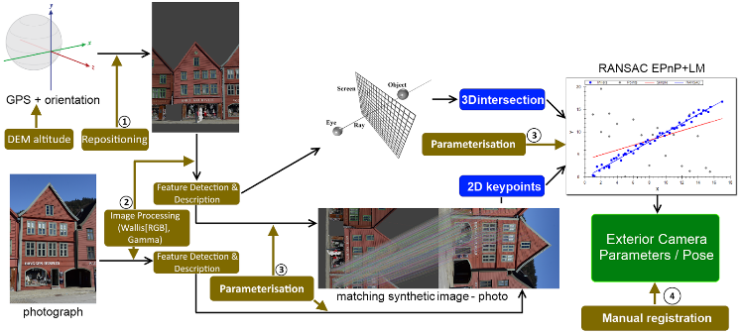

**Fig. 1.** Main workflow for feature-based, mobile sensor-assisted image-to-geometry registration.

**3 Challenges**

Despite being tested on synthetic- as well as domain-specific case studies (e.g. cultural heritage, hydrology, geology) in past years, the available methods for feature-based registration, are still far away from being fully-automatic. Applying the previous concepts still presents distinct challenges in real-world scenarios and for mobile device platforms, which are discussed in this section.

3.1 Device Variability

Android by itself is a very open to use operation system and enables many manufactures the development of various smartphones using a wide-spread operation system. But, this high variability leads to abound in the market of on-board sensors, cameras and processing units. All kinds of sensors like the main camera vary strongly in their qualities (low-cost versus flagship phone). These are quite complicating factors for providing apps for e.g. crowdsourcing-based volunteered geographic information (VGI) acquisition [9,26,32] using the public equipped with several types of phones. Measurements resulting from smartphone images are strongly correlated with the camera quality itself regarding their reliability, accuracy and spatial resolution. Furthermore, a too small processing unit can refuse the whole data processing whereas a highly susceptible IMU impedes the acquisition of suitable initial orientation data which is indispensable for a precise image-to-geometry intersection.

Another concern deals with the graphics computing capabilities. The rendering of a given 3D model is done on GPU via OpenGL. Apart from the natural hardware performance differences, the employed graphics chips (e.g. Qualcomm Adreno, ARM Mali, NVIDIA Tegra) on support different rendering instructions, like texture support. For textured surface models (often used in feature-based matching), on-chip texture decompression makes a significant difference in rendering speed. Also, whereas most tablet brands use Qualcomm’s system-on-a-chip (SoC) architecture, where CPU and GPU share the same memory, other devices provide dedicated graphics memory that speeds up rendering significantly. On top of the rendering-related differences, some graphics processors (e.g. Mali and Tegra) provide non-graphics related GPU Computing capabilities via OpenCL and CUDA, which allows for drastic runtime reductions for future, optimised image-to-geometry systems [17,19].

3.2 Camera intrinsics

Both, photogrammetric measurements and computer vision that use cameras for data acquisition for image processing tasks like visual odometry, 3D modelling or even monitoring purposes should deal with the issue of camera calibration. Camera calibration comprises the determination of its intrinsic (principle point, focal length and skew) and several lens distortion parameters (e.g. radial and tangential distortion). Therefore, numerous techniques for camera modelling are well-known [43,46,7] and not further addressed in this paper.

In case of typical consumer cameras like digital single lens reflection cameras (DSLR), the calibration is valid for one camera setting concerning focal aperture, length and focus adjustments and can be fixed easily by avoiding manual refocusing and aperture tuning. Today’s smartphones and tablets are largely equipped with inbuilt autofocussing cameras which are used by several apps (camera application, QR detection, AR games, etc.). Even if a camera application uses manual focussing, the camera will be refocused during each app start and affects the intrinsic (Tab 1). If a mobile smartphone camera should be used for measurements and thus should be calibrated, the mentioned problem can only be avoided if calibration and data acquisition are consecutive without closing the app. However, when running the camera app continuously the battery runs out quickly. Beside this, the devices temperature changes very fast when other apps, microelectromechanical systems (MEMS) or GPS are started or closed from background processing tasks. Obviously, this must influence the small inbuilt camera sensors and lenses due to hardware assembling and adhesive bond (tab 2).

|  |  |  |  |  |  |  |  |  |  |  |  |  |
| --- | --- | --- | --- | --- | --- | --- | --- | --- | --- | --- | --- | --- |
| ObjectPoint | | | 1st run | | 2nd run | | 3rd run | | Diff 1st – 2nd | | Diff 1st – 3rd | |
| X | Y | Z | x | y | x | y | x | y | x | y | x | y |
| 0 | 0 | -0.0 | 1653.15 | 1222.70 | 1639.67 | 1220.53 | 1638.55 | 1213.08 | 13.48 | 2.16 | 14.60 | 9.62 |
| -2.5 | -2.0 | 0.0 | 3097.37 | 2378.07 | 3092.64 | 2382.90 | 3076.34 | 2363.32 | 4.73 | -4.83 | 21.03 | 14.75 |
| -2.5 | 2.0 | 0.0 | 3097.37 | 67.33 | 3092.66 | 58.14 | 3076.34 | 62.85 | 4.71 | 9.19 | 21.03 | 4.48 |
| 2.5 | -2.0 | 0.0 | 208.93 | 2378.07 | 186.71 | 2382.99 | 200.75 | 2363.32 | 22.23 | -4.83 | 8.18 | 14.75 |
| 2.5 | 2.0 | 0.0 | 208.94 | 67.33 | 186.69 | 58.14 | 200.76 | 62.85 | 22.24 | 9.19 | 8.18 | 4.48 |

Tab. 1: App restarts affecting camera intrinsics (configuration and focal length [∞] persist). Description of projected object points to image plane using re-determined camera parameters and radial distortion for three reboots.

|  |  |  |  |  |  |  |  |  |  |  |  |  |  |  |
| --- | --- | --- | --- | --- | --- | --- | --- | --- | --- | --- | --- | --- | --- | --- |
| ObjectPoint | | | ImgPt (37°C) | | ImgPt (57°C) | | Diff | | ImgPt (37°C) | | ImgPt (57°C) | | Diff | |
| X | Y | Z | x | y | x | y | x | y | x | y | x | y | x | y |
| 0 | 0 | -0.0 | 1653.15 | 1222.70 | 1634.76 | 1222.16 | 18.39 | 0.53 | 1639.67 | 1220.53 | 1652.13 | 1226.86 | -12.46 | -6.33 |
| -2.5 | -2.0 | 0.0 | 3097.37 | 2378.07 | 3076.65 | 2375.67 | 20.72 | 2.40 | 3092.64 | 2382.90 | 3100.15 | 2385.27 | -7.50 | -2.37 |
| -2.5 | 2.0 | 0.0 | 3097.37 | 67.33 | 3076.66 | 68.64 | 20.71 | -1.31 | 3092.66 | 58.14 | 3100.15 | 68.44 | -7.49 | -10.30 |
| 2.5 | -2.0 | 0.0 | 208.93 | 2378.07 | 192.87 | 2375.67 | 16.06 | 2.40 | 186.71 | 2382.99 | 204.12 | 2385.27 | -17.42 | -2.37 |
| 2.5 | 2.0 | 0.0 | 208.94 | 67.33 | 192.86 | 68.64 | 16.08 | -1.31 | 186.69 | 58.14 | 204.11 | 68.44 | -17.42 | -10.30 |

Tab. 2: Calefaction of device affecting camera intrinsics (configuration persists). Description of projected object points to image plane using re-determined camera parameters and radial distortion for two observations. Camera app in foreground.

3.3 Location- and Orientation Sensor Data Quality

Most of today’s smartphones share inbuilt MEMS for orientation tasks from simple screen orientation determination up to navigation purposes. Commonly, MEMS comprise 3-axis accelerometers, 3-axis gyroscopes, magnetometers and gravity sensors. Barometers are increasingly integrated. It seems to be obvious that this kind of low-cost inertial measurement units (IMUs) cannot be comparable in resolution and stability due to lowest production cost. For Apple’s iPhone and Samsung’s Galaxy series (until 2014) it should be noted, that sensors share less than 5 % of the production costs and range between 1.60 and 7.00 USD [29]. In comparison to that, even light IMU’s for e.g. airborne applications like drone navigation amount to several hundred dollars. Nevertheless, due to various kinds of orientation sensors, sensor fusion and filtering help to solve the issue of noisy accelerometers and drifting gyroscopes that accumulate their errors respectively over time. Using their complementary characteristics, sensor fusion and implementation of filtering approaches could improve orientation accuracy and stability significantly [25,38].

Fig. 2 shows stability test results of the azimuth, pitch and roll angles remapped to landscape mode using the Android smartphone Samsung Galaxy S8 and a Kalman filtered fusion of the inbuild accelerometer, gyroscope and compass combined with the calibrated gyroscope (implementation according to [38]). Furthermore, the azimuth includes magnetometer information pointing to the geographic north after correction by declination. Up to this, the smartphone was mounted on a tripod and installed apart from magnetic impurities like other smartphones or computers.

|  |  |  |  |  |
| --- | --- | --- | --- | --- |
|  | Time [sec] | **σAzimuth [°]** | **σPitch [°]** | **σRoll [°]** |
| 5 | 0,00572 | 0,00091 | 0,00205 |
| 10 | 0,00596 | 0,00301 | 0,00192 |
| 15 | 0,00605 | 0,00326 | 0,00417 |
| 20 | 0,00746 | 0,00681 | 0,00677 |
| 25 | 0,00860 | 0,01019 | 0,00891 |
| 30 | 0,01010 | 0,01108 | 0,01078 |
| 35 | 0,01186 | 0,01037 | 0,01210 |
| 40 | 0,01311 | 0,00985 | 0,01270 |
| 45 | 0,01291 | 0,01025 | 0,01222 |
|  | | | | |

**Fig. 2.** Stability test for orientation assessment using a Samsung Galaxy S8 smartphone and sensor fusion [38] for increasing precision and stability regarding azimuth, pitch and roll angles.

Registration setups with a global reference frame (i.e. not based on motion- and temporal sensor correlation) rely on common GPS data and absolute, geomagnetic orientation. Magnetic orientation is measurably influenced by magnetic impurities in close proximity, as often found in urban areas [4]. This inhibits correct orientation in 3D inside cities, but for planar orientation it is less problematic. In most outdoor applications [36] and especially for 3D Image-to-Geometry registration, the sensor accuracy currently needs to be assessed on a per-case basis [Kehl2016?]. The GPS accuracy can be improved in urban areas via terrestrial network connection [45], which demands WiFi access. When dealing with raw GPS data, the location accuracy drops significantly. Lateral errors of up to 8 metres and vertical errors of tens of metres are realistic outdoor GPS limits [Kehl2016?,21].Resolving the geo-positioning accuracy limitation in the future may be a result of two major changes: (a) dropping differential GPS prices and (b) the computationally more manageable integration of real-time kinematics (RTK) and temporal sensor filtering (similar to sensor fusion for IMU approaches [31]) into the sensor software framework within Android. Currently, a comprehensible, user-driven re-positioning via DEMs resolves drastic sensor errors occurring outdoors [21]. These can be obtained via open-data media, e.g. Digital Earth Explorer[1]. Currently, global improvement of sensor accuracy is the focus of intense investigations.

3.4 Image Mapping under Natural Illumination

Feature-based registration relies on an unambiguous, robust point-to-point correlation via distinctive feature vectors. As such, it is affected by distortions and content appearance changes, referred to as geometric- and radiometric variance. Radiometric variance, caused by environmental effects and natural illumination changes, still are still problematic for feature correlation. Recent studies have shown that some combinations of already-available techniques are robust against geometric- and radiometric distortion [Kehl2017?] as illustrated in Fig. 3. Still, feature descriptors that account for the radiometric variance are in high demand. A major contribution to this research track would be the integration of local colour attributes to the feature space, as formerly used for image classification methods [44].

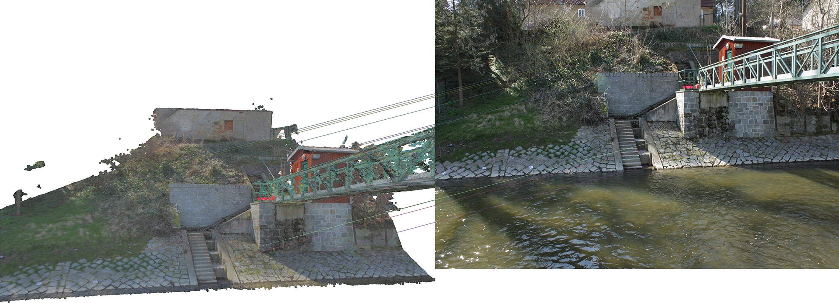

a) MCER

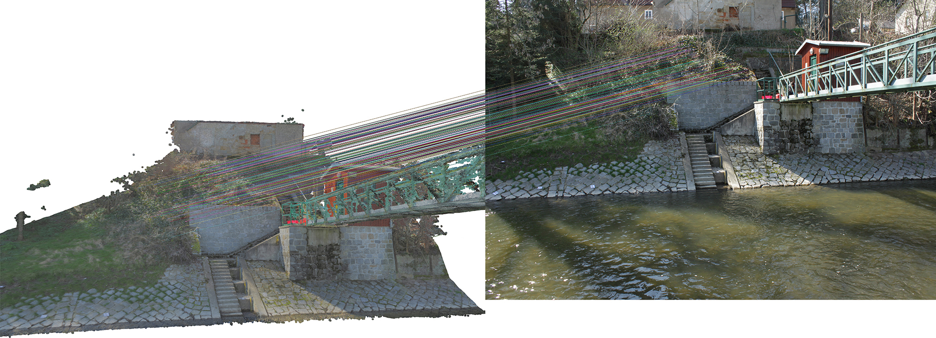

b) SIFT

**Fig. 3.** Feature detection using a) MSCR (inlier: 11, wide-centred distribution), b) SIFT (inlier: 186, highly-centred distribution).

3.5 Mapping requirements

Regarding accuracy requirements for environmental monitoring purposes and image-to-geometry intersection, the application is related to camera-to-subject distances of several meters. As figured out in section 3.1, inbuilt smartphone or tablet cameras vary widely in their capabilities. Considering the mid-price phone Google Nexus 5 (camera specs: sensor: 4.54x3.42 mm, pixel size:1.39 µm, focal length ~4 mm, crop~7.6) and a characteristic distance of 20 m, 1 pixel represents 1 cm in object space. Thus, natural features of a few centimetres should be in place to allow the application of the mentioned approach (see section 2).

3.5 Performance Requirements

The methods being employed for image-to-geometry registration on mobile devices are depended on the required performance (i.e. computation) time of the algorithm as well as the methodological constraints of the application domain. While mobile graphics and computations made significant advances in recent years [13,24,1], a major problem is to scale up lab-sized results (with respect to 3D model- and image size) to actual application demands. This is because mobile devices are memory-limited – in strict contrast to most desktop- and laptop computing platforms.

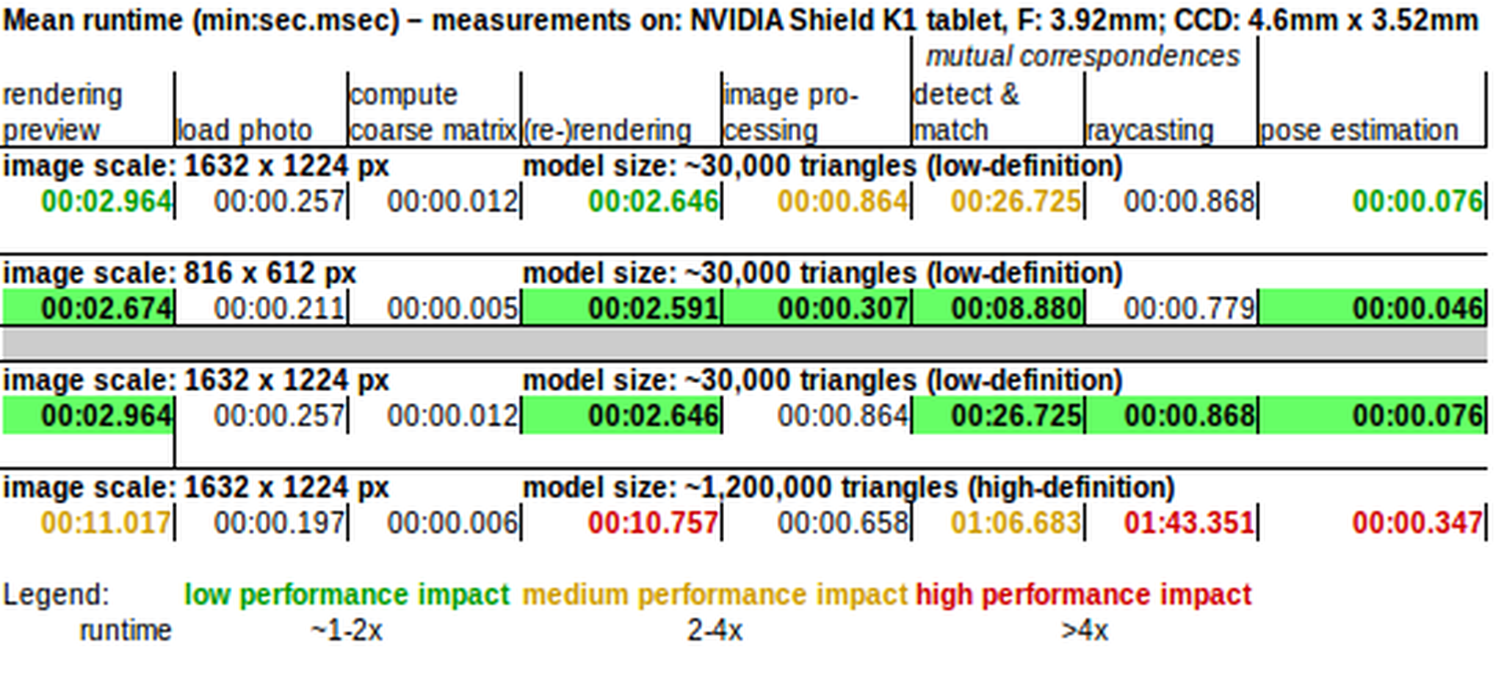

**Tab. 1.** Check computation performance: varying image scales (fixed model size), registration of half-resolution images to low-resolution models, registration of half-resolution images to high-resolution models (valid for tablets with dedicated GPUs, e.g. NVIDIA Tegra).

In cases where the application constraints allow to use the mobile device as plain input sensor and output presentation platform, it is common to use the WiFi connection for image- and sensor data transmission while the actual processing is being done on a remote server. Examples for this approach can be found in SfM reconstruction [12], mobile rendering [39]. The possibility of using network connectivity also reduces the energy consumption of the registration process on the mobile devices itself, which makes sensor tracking more viable for increasing the location- and orientation accuracy. The specific challenge is then to define a trade-off between network transmission load and tasks that are done locally on the device.

In cases where network connectivity is not available or not being used, performance is a much more limiting factor of what can algorithmically be achieved. The computational complexity of feature-based geometry is linked to the image resolution and size of the 3D surface model (see Tab.1). The effect is commonly mitigated on desktop hardware due to CPU vectorisation, SSE instructions and GPU-based image filtering, which are not available on mobile hardware architectures. Lower-resolution images speed up the calculation but also result in less-accurate feature matching in general. Furthermore, the rendering of the 3D model – marginally contributing to the computation runtime on desktops – is slow and restrictive (in terms of model size) on mobile devices, meaning that it contributes majorly to the algorithmic runtime. The computational complexity relates to a given energy budget used to register an image, which is a drawback for extended utilisation of the technology for some application domains.

**4 Applications**

Volunteered Geographic Information (VGI) becomes growing attention concerning multiple areas of geosciences. Section 4 highlights two important topics which could be highly improved by complementary VGI. Crowdsourcing seems to be very helpful for mobile data acquisition in case of “geo-events” (like floods or landslides) with high spatial and temporal resolution where they are needed most. Thus, it is obvious that captured data by smartphones -comprising image, position and orientation data- must be fused and translated from the device to the object space. This is where the mobile image-to-geometry intersection comes in. In the following, two major fields are presented that profit from mobile data acquisition depending on the mentioned topic.

4.1 Hydrology

Regarding worldwide increasing flood hazards, there is an enormous increase in the importance of river monitoring including flow velocities, water levels and river cross sections. Conventional gauging stations are most solely installed which would lead to an insufficient coverage of hydrographic data when they are most needed – like sudden flood events. Even small running water catchments can turn in devastating streams that pose threat to the environment and to human health. With aid of the public, mobile data could be acquired quickly and could be used for spatio-temporal densification of hydrologic data [26,10,27]. Short time lapse smartphone image sequences with known initial pose and orientation could be used to determine the river line that could be further intersected with prevailing object data. In that way, the detected shore could be transferred into several water levels. For this, the shore area should be visible inside of the image and must provide sufficient information for image-to-geometry intersection in terms of buildings, stones or other artificial objects (see section 2).

4.2 Petroleum Geology

The feature-based registration on textured triangle meshes is integrated in the Geological Registration and Interpretation Toolkit (GRIT), a 2D-3D mobile application for smartphones and tablets to study geological rock exposures (i.e. outcrops). Geological studies include several purposes ranging from sedimentary architecture reconstruction (e.g. SAFARI project [18]) over structural studies for flow analysis to structural studies for geothermal prospect evaluation. In the case of GRIT, the technology has been applied on sedimentology case studies at Mam Tor, Derbyshire, UK [22,20] and an oil reservoir analogue study at the Saltwick Formation, Whitby, North Yorkshire, UK [21] (fig. 6).

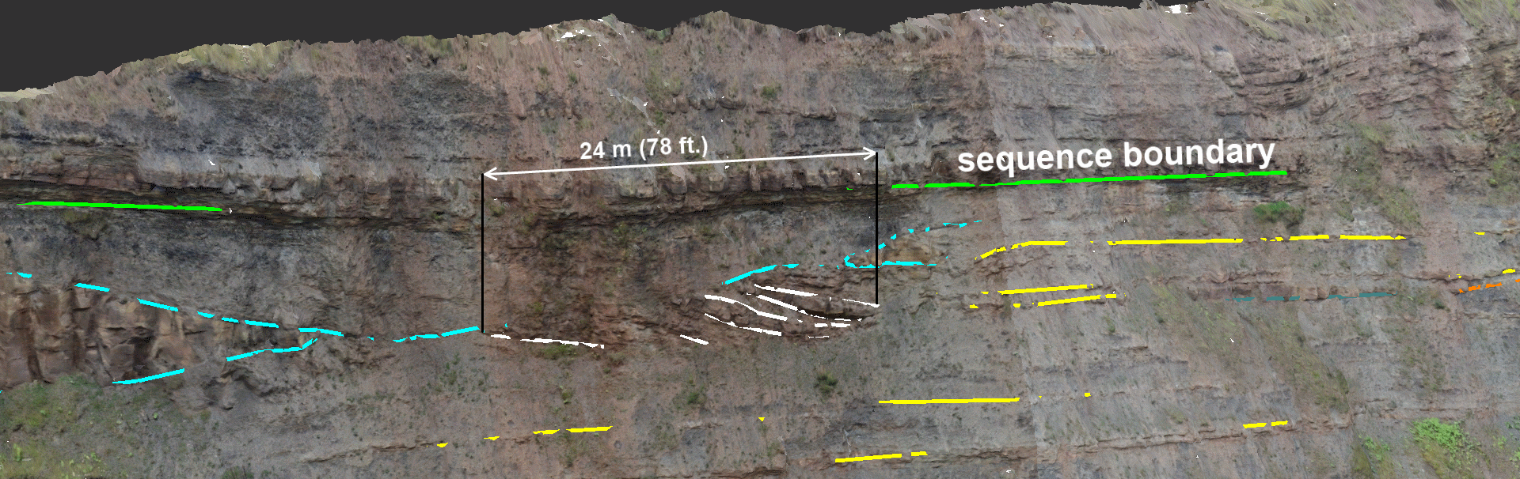

**Fig. 6.** 3D-registered interpretations of the Saltwick Formation (North Yorkshire, UK) geological case study highlighting the sandstone channel architecture of the North Sea cliff section outcrop.

A case study at Calvisson, department Gard, France was used to gain insight into fracture networks [3] and their interconnectivity to more reliably predict multi-phase flow (i.e. combined flow of multiple, heterogeneous fluids) in subsurface reservoirs with strong deformation patterns. Further investigations are planned in the soon future.

Additionally, the mobile device application is envisaged to be used on further geothermal research studies in Mexico, as well as sedimentary studies for carbon capture- and storage (CCS) projects of local coal power plants.

**Acknowledgements**

The VOM2MPS (i.e. the research of Uni Research-affiliated authors) is funded as a Petromaks 2 project (no. 234111/E30) by the Research Council of Norway and the Force consortium, while data (e.g. Yorkshire datasets) are provided by SAFARI ([www.safaridb.com](http://www.safaridb.com)). Data from Calvisson where collected and provided through an industry-funded research project by TOTAL.

Gratefully, acknowledge is given to the European Social Fund (ESF) and the Free State of Saxony for their financial support on a grant (funding no. 100235479, period: 01.10.2015 - 31.12.2018).

**References**

1. Agus, M., Gobbetti, E., Marton, F., Pintore, G., & Vázquez, P. P. (2017). Mobile Graphics. EuroGraphics 2017 – Tutorials. The Eurographics Association.
2. Baboud, L., Čadík, M., Eisemann, E., & Seidel, H. P. (2011, June). Automatic photo-to-terrain alignment for the annotation of mountain pictures. In Computer Vision and Pattern Recognition (CVPR), 2011 IEEE Conference on (pp. 41-48). IEEE.
3. Bisdom, K., Gauthier, B. D. M., Bertotti, G., & Hardebol, N. J. (2014). Calibrating discrete fracture-network models with a carbonate three-dimensional outcrop fracture network: Implications for naturally fractured reservoir modeling. AAPG bulletin, 98(7), 1351-1376.
4. Blum, J. R., Greencorn, D. G., & Cooperstock, J. R. (2012, December). Smartphone sensor reliability for augmented reality applications. In International Conference on Mobile and Ubiquitous Systems: Computing, Networking, and Services (pp. 127-138). Springer, Berlin, Heidelberg.
5. Bodensteiner, C., Hebel, M., & Arens, M. (2010, September). Accurate Single Image Multi-modal Camera Pose Estimation. In ECCV Workshops (1) (pp. 296-309).
6. Boerner, R. & Kröhnert, M. (2016). Brute force matching between camera shots and synthetic images from point clouds. Int. Arch. Photogramm. Remote Sens. Spatial Inf. Sci., XLI-B5, 771-777.
7. Brown, D. C. (1971). Close-range camera calibration. In Photogrammetric Engineering, 37(8), 855-866.
8. Caron, G., Dame, A., & Marchand, E. (2014). Direct model based visual tracking and pose estimation using mutual information. Image and Vision Computing, 32(1), 54-63.
9. Duchateau, R., & Mackaness, W. A. (2017). Smartphone-based volunteered geographic information for land registration: the case of the Scottish crofting community.
10. Eltner, A., Sardemann, H., Kröhnert, M. & Schwalbe, E. (2017). Camera based low-cost system to monitor hydrologic parameters in small catchments. EGU General Assembly Conference Abstracts 19.

Ericsson (2017). Ericsson Mobility Report. August 2017. Stockholm: Ericsson. Retrieved September 02, 2017 from   
[https://www.ericsson.com/assets/local/mobility-report/  
documents/2017/ericsson-mobility-report-interim-update-august-2017.pdf](https://www.ericsson.com/assets/local/mobility-report/documents/2017/ericsson-mobility-report-interim-update-august-2017.pdf)

1. Fritsch, D., & Syll, M. (2015, March). Photogrammetric 3D reconstruction using mobile imaging. In SPIE/IS&T Electronic Imaging (pp. 94110C-94110C). International Society for Optics and Photonics.
2. García, S., Pagés, R., Berjón, D., & Morán, F. (2015, June). Textured splat-based point clouds for rendering in handheld devices. In Proceedings of the 20th International Conference on 3D Web Technology (pp. 227-230). ACM.
3. Gauglitz, S., Sweeney, C., Ventura, J., Turk, M., & Höllerer, T. (2014). Model Estimation and Selection towardsUnconstrained Real-Time Tracking and Mapping. IEEE transactions on visualization and computer graphics, 20(6), 825-838.
4. Google (2016). Android - Project Tango. Project Website, URL: <https://get.google.com/tango/>.
5. Guislain, M., Digne, J., Chaine, R., & Monnier, G. (2017). Fine scale image registration in large-scale urban LIDAR point sets. Computer Vision and Image Understanding, 157, 90-102.
6. Heymann, S., Müller, K., Smolic, A., Fröhnlich, B. & Wiegand, T. (2007). SIFT Implementation and Optimization for General-Purpose GPU. Winter School of Computer Graphics (WSCG). Eurographics.
7. Howell, J. A., Martinius, A. W., & Good, T. R. (2014). The application of outcrop analogues in geological modelling: A review, present status and future outlook. Geological Society, London, Special Publications, 387(1), 1-25.
8. Hudelist, M. A., Cobârzan, C., & Schoeffmann, K. (2014, April). OpenCV performance measurements on mobile devices. In Proceedings of International Conference on Multimedia Retrieval (p. 479). ACM.
9. Kehl, C., Buckley, S., Viola, I., Viseur, S., Gawthorpe, R., Howell, J. (2017a): Automatic Illumination-Invariant Image-to-Geometry Registration in Outdoor Environments. The Photogrammetric Record 32(158).
10. Kehl, C., Buckley, S., Viseur, S., Gawthorpe, R. L., Mullins, J. R. & Howell, J. A. (2017c, December). Mapping field photos to textured surface meshes directly on mobile devices. Accepted for publication in: The Photogrammetric Record.
11. Kehl, C., Buckley, S., Gawthorpe, R., Viola, I., Howell, J. (2016a): Direct Image-to-Geometry Registration Using Mobile Sensor Data. ISPRS Annals of Photogrammetry, Remote Sensing & Spatial Information 3(2), pp.121-128.
12. Kehl, C., Buckley, S. (2016b): Automatic Image-to-Geometry Registration in Varying Illumination Conditions using Local Descriptors. Proceedings of 19th 3D NordOst, Berlin, pp. 151-160.
13. Kehl, C., Buckley, S., Howell, J. (2015a): Image-to-Geometry Registration on Mobile Devices - An Algorithmic Assessment. Proceedings of 18th 3D NordOst, Berlin, pp.17-26.
14. Kok, M., Hol, J. D., & Schön, T. B. (2017). Using inertial sensors for position and orientation estimation. arXiv preprint arXiv:1704.06053.
15. Kröhnert, M. & Meichsner, R. (2017). Segmentation of environmental time lapse image sequences for the determination of shore lines captured by hand-held smartphone cameras. ISPRS Ann. Photogramm. Remote Sens. Spatial Inf. Sci., IV-2/W4, 1-8.
16. Kröhnert, M. (2016): Automatic Waterline Extraction from Smartphone Images. International Archives of the Photogrammetry, Remote Sensing and Spatial Information Sciences XLI(B5), pp.857-863.
17. Lepetit, V., Moreno-Noguer, F., & Fua, P. (2009). Epnp: An accurate o (n) solution to the pnp problem. International journal of computer vision, 81(2), 155-166.
18. Lewin, S. (2014). The smartphone recipe. IEEE Spectrum, 51(12): p 80.
19. Li, S., Xu, C., & Xie, M. (2012). A robust O (n) solution to the perspective-n-point problem. IEEE transactions on pattern analysis and machine intelligence, 34(7), 1444-1450.
20. Ligorio, G., & Sabatini, A. M. (2013). Extended Kalman filter-based methods for pose estimation using visual, inertial and magnetic sensors: Comparative analysis and performance evaluation. Sensors, 13(2), 1919-1941.
21. Linquist, M. & Galpern, P. (2016) Crowdsourcing (in) Voluntary Citizen Geospatial Data from Google Android Smartphones. Journal of Digital Landscape Architecture, 1-2016. Herbert Wichmann Verlag, VDE VERLAG GMBH, Berlin/Offenbach, p. 263-272.
22. Madsen, K., Nielsen, H. B., & Tingleff, O. (2004). Methods for non-linear least squares problems.
23. Meek, S., Priestnall, G., Sharples, M., & Goulding, J. (2013). Mobile capture of remote points of interest using line of sight modelling. Computers & geosciences, 52, 334-344.
24. Meierhold, N. & Schmich, A. (2009). Referencing of images to laser scanner data using linear features extracted from digital images and range images. In: International Archives of Photogrammetry, Remote Sensing and Spatial Information Science Vol. XXXVIII-3/W8.
25. Novakova, L., & Pavlis, T. L. (2017). Assessment of the precision of smart phones and tablets for measurement of planar orientations: A case study. Journal of Structural Geology, 97, 93-103.
26. Nuernberger, B., Lien, K. C., Grinta, L., Sweeney, C., Turk, M., & Höllerer, T. (2016, November). Multi-view gesture annotations in image-based 3D reconstructed scenes. In Proceedings of the 22nd ACM Conference on Virtual Reality Software and Technology (pp. 129-138). ACM.
27. Pacha, A. (2015). Sensor Fusion for Robust Outdoor Augmented Reality Tracking on Mobile Devices. GRIN Verlag, USA.
28. Ponchio, F., & Dellepiane, M. (2016). Multiresolution and fast decompression for optimal web-based rendering. Graphical Models, 88, 1-11.
29. Sottile, M., Dellepiane, M., Cignoni, P., & Scopigno, R. (2010). Mutual Correspondences: An Hybrid Method for Image-to-geometry Registration. In Eurographics Italian Chapter Conference (pp. 81-88).
30. Stelling, N.; Spehr, B.; Schilling, A.; Maas, H.-G.; Gumhold, S. (2010). Automatic feature matching between digital images and 2D representations of a laser scanner point cloud. In: International Archives of Photogrammetry, Remote Sensing and Spatial Information Sciences Vol. 38, Part 5.
31. Sweeney, C., Flynn, J., Nuernberger, B., Turk, M., & Höllerer, T. (2015, September). Efficient computation of absolute pose for gravity-aware augmented reality. In Mixed and Augmented Reality (ISMAR), 2015 IEEE International Symposium on (pp. 19-24). IEEE.
32. Tsai, R. (1987). A versatile camera calibration technique for high-accuracy 3D machine vision metrology using off-the-shelf TV cameras and lenses. IEEE Journal on Robotics and Automation, 3(4), 323-344.
33. Van De Weijer, J., & Schmid, C. (2006). Coloring local feature extraction. Computer Vision–ECCV 2006, 334-348.
34. Wang, J., Schindler, G., & Essa, I. (2012, September). Orientation-aware scene understanding for mobile cameras. In Proceedings of the 2012 ACM Conference on Ubiquitous Computing (pp. 260-269). ACM.
35. Zhang, Z. (2000). A flexible new technique for camera calibration. IEEE Transactions on pattern analysis and machine intelligence, 22(11), 1330-1334.

1. Digital Earth Explorer – https://earthexplorer.usgs.gov